Georgian International Energy Corporation

Installation of instrumentation and control system with local SCADA
"Alazani 2" Hydro power plant
Technical requirements

Turn-key solution purchase

Tbilisi 2021

Table of Contents
Table of Contents 2
Introducion 3
1. Scope of work 4
2. Requirements to the turbine governor modernization 5
3. Requirements to local SCADA 6
4. Requirements to the PLC for auxiliaries 8
5. Terms of Use 9
6. The requirement for the composition and parameters of technical means 10
7. Basic structure of SCADA systems in GIEC 11
8. Basic Structure of SCADA Systems in GIEC 13
8.1 Technical Description of HPP 13
a. One-line Scheme of HPP 14
8.3 Connection of HPPs with Internet 15

Introducion
This technical task is intended for the installation of instrumentation and control system (hereinafter I&C) and local SCADA systems at GIEC-s power plants. Software complexes of this class are used as an element of automation systems for industrial processes. This moment we are talking about the production of electric energy at the GIEC hydro power plants.
There are two stages of purchasing and implementation procedures during which the new automation concept is due to be implemented.
The current stage means the creation of local I&C and SCADA systems at hydro power plants (hereinafter HP) locally, which consists of:
- measuring sensors;
- executive mechanisms;
- controllers for collecting data from sensors, their processing and issuing control actions;
- connectivity and data transfer from/to local subsystems;
- local SCADA systems;
- network equipment and firewall solution.
Another stage means creation of a central SCADA systems (not the subject of the current document).

- Scope of work
By this project, the contractor has to install I&C system and local SCADA for Alazani 2 HPP. The scope of work includes, but is not limited to, integrating following equipment into plant I&C system with local SCADA:
- Turbine Model YNT-1800-T governors with necessary sensors;
- Existing excitation system;
- Existing control cabinet of oil lubrication system;
- Existing cabinet of measurement equipment;
- Existing cabinet of control valve operation;
- Existing emergency diesel generating set;
- Direct current cabinet (auxiliary contacts states);
- Fire alarm state from existing fire alarm system;
- Electrical counters;
- 6,3kV distribution cubicles (auxiliary contacts states).

On the plant level following activities have to be performed:

- Installation of local SCADA
- Installation of PLC system to provide monitoring of auxiliaries.
- Network equipment requirements
- DMZ zone or firewall solution to secure Internet connection and transfer data safely to the central SCADA system.

- Requirements to the turbine governor modernization
The contractor has to perform following modernization for each hydro turbine Model YNT-1800-T and auxiliary equipment Hydro plant auxiliary equipment:
- General requirement: the new system has to provide autonomous functioning without presence and intervention of operating staff by implementing automated regulation and functional group control in all operating modes applied to hydro power plants:
  - Automated load supply;
  - implementation of technological protections in accordance with the requirements of equipment manufacturers;
  - the possibility of participating in maintaining the frequency and power of the power system at the request of the transmission system operator;
  - Operation of all auxiliary mechanisms and systems without constant intervention of operating personnel;
  - Maintaining the level in the forebay;
  - Possibility of transfer to manual control.
- Replacement of Turbine speed regulator hardware of hydro power generators;
- Software analysis and diagnostic of turbine governor for each controller. The new software project is due to be provided by the contractor with the complete set of installation and commissioning services;
- Provide revision and, if necessary, replacement of all instrumentation installed on the turbines and auxiliary equipment;
- Check the power management system, microcontroller functionality, interfaces performance and software;
- Provide revision and, if necessary, replacement of mechanical and hydromechanical nodes, namely: speed regulator rocker, sharp servo motor, isodrome gear, pull-down mechanism, high pressure pump and pump drive, speed ​​regulator connection and feedback with electronic automatic control mechanism;

- Requirements to local SCADA
Currently, there are a fairly large number of SCADA systems. The vast majority of them work under Windows OS of the NT family (iFIX from Intellution (USA), Genesis software package (USA), InTouch of WonderWare corporation (USA, “pioneer” in the field of “SCADA under Windows”), WinCC from Siemens (Germany), Trace Mode from Adastra (Russia)).
At the same time, the SCADA market for Unix-like OSs (in particular, Linux) is presented much more modestly: ScadaBase from MODCOMP, Linux PRISM SCADA from Advanced Control Systems, AccessPoint from Accessware, etc.
It is desirable to use one of them to create local SCADA systems, higher specified software, as a part of local I&C of hydropower plant.
For SCADA systems, it must have a program of visualizations on the monitor of the operator's computer and the service manager, and the management of energy networks. And SCADA visualization subsystems should be as follows:
visualizations:
• operational information: values of the parameters of the production process, violations of the parameters of regulatory boundaries (alarms);
• archived data: parameter values; text messages about violations of production processes, user actions to manage processes, as well as system messages from all ICS and SCADA subsystems;
management of technical equipment and process parameters that took place at hydroelectric power stations: changes in settings and operating modes of control loops, changes in system settings, input of numerical data.
Application of SCADA systems together with the visualization subsystem and ICS systems should provide:
• improving the quality of electric energy due to:
• prompt submission of information to the maintenance staff about the condition of the equipment and the processes taking place in the hydroelectric station in real time;
• automated start and stop of technical equipment;
• monitoring the actions of operators managing technical equipment;
• archiving parameters of technical and technological processes during the generation of electric energy;
Improving the safety of production processes by ensuring the operation of technological equipment without a permanent presence in the area of its deployment of operational personnel.
There is also a need to install new ICS systems. The following devices and equipment should be installed at hydroelectric power plants of subordinates of the Hydroenergo Department for technical re-equipment: digital thyristor excitation systems on 4 units, hydraulic unit speed controller with digital control and monitoring systems on 12 units, digital relay protection systems on 12 units and distribution networks at 5 hydroelectric power stations, digital technological protections at 12 units, digital thermal monitoring systems at 12 units, digital monitoring and control systems at 18 units at 5 Hydroelectric power station. System of Supervisory Control and Data Acquisition (SCADA) in 5 hydroelectric power stations.
The management functions of technical and technological equipment and the parameters of the production process should provide:
• remote and local control of discrete actuators, operating modes;
• operator input of analog and digital values;
• there should be a mechanism for confirming the execution of an operator’s command, fixing the operator’s actions in the message subsystem, as well as delimiting the rights of operators and dispatchers to execute commands.
Operator control commands, production processes, single-line circuits, regulators, excitation and navigation systems within the subsystem must be made using the keyboard and mouse.
The SCADA visualization subsystem in the process of its functioning as input must use the data of the following SCADA subsystems located on sections of the entire system:
• subsystem of current parameter values - to obtain a list of production process parameters and their attributes, parameter values, control of generators and networks;
• subsystems of archives - to display archived values of the parameters of the production process, the entire system and display messages about the arrival of various kinds of events;
• security subsystems - to get a list of registered users.
The output information of the visualization subsystem is:
• image on the display;
• the operator’s current values of the parameters of the production process (for example, the controller’s operating mode, the controller’s task, the controller’s output, controller’s settings, remote excitation control, remote control of switching equipment, etc.) that enter the parameter subsystem.
The local SCADA has to visualize the process from all the equipment connected to the PLCs delivered by the contractor. The visualization standards, the number and type of plant displays as well as functionality are due to be agreed on the design phase.

- Requirements to the PLC for auxiliaries
Under the term PLC for auxiliaries a separate industrial type CPU with necessary amount of I/O is meant. The purpose of the local PLC is to collect the data from following groups of equipment, to integrate the data with PLCs of the turbine governors and local SCADA:
- Existing cabinet of control valve operation;
- Existing emergency diesel generating set;
- Direct current cabinet (auxiliary contacts states);
- Fire alarm state from existing fire alarm system;
- Electrical counters;
- 6,3kV distribution cubicles (auxiliary contacts states).

The PLC for auxiliaries must be placed in a separate cabinet and connected to the existing equipment by wires. The wiring constructions have to be installed where is needed. The number of signals from each auxiliary equipment has to be agreed with the customer.
Additionally, the cabinet has to be equipped with a firewall to secure external network connection. The contractor is responsible for providing a complete solution to organize the data exchange with the central SCADA.
The PLC for auxiliaries has to be from the same vendor as turbine governor PLCs, all PLCs have to be connected to a common automation network and connected to the local SCADA.
The structure of PLCs and SCADAs interconnection are shown on the picture below.
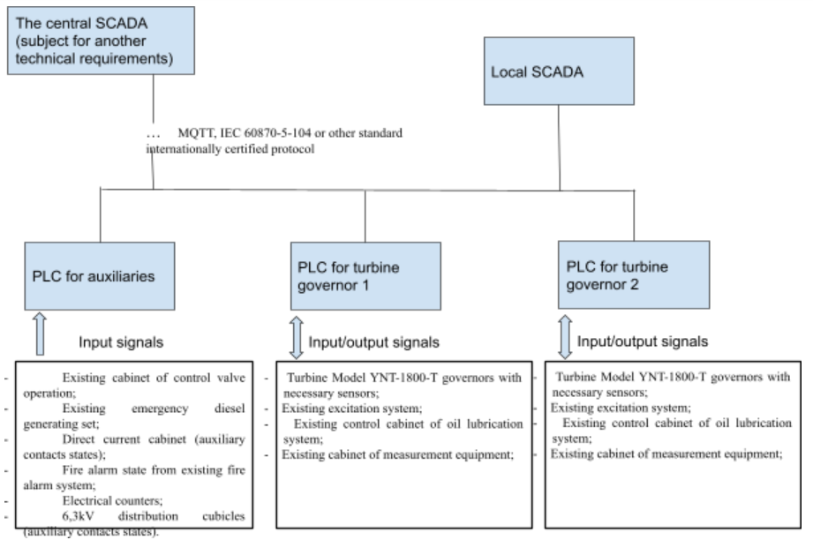
- Terms of Use
To ensure the reliable functioning of SCADA systems at the operator’s hydroelectric station and at the control room, it is necessary to ensure the following conditions:
• temperature: 20-25 ° C;
• humidity: 40-60%
The qualifications of the personnel servicing the software and hardware of ICS and SCADA should ensure the effective functioning of the system in all specified modes and meet the requirements for the corresponding categories of workers adopted at hydroelectric stations.
The ICS for the production of electric energy should be serviced by personnel who have undergone training and knowledge testing according to the rules for safe work with the software and hardware of the system in the manner adopted by the enterprise, and taking into account the requirements of organizational support instructions.
Specialists serving the software and hardware of the ACS for the production of electricity should have:
• sufficient knowledge to:
• perform operations to implement the corresponding automated and interconnected non-automated functions of ACS, the production of electric power and the operation of hydrogenerators;
• making the right decisions in emergency situations or other violations of normal operation;
Skills that allow you to perform all maintenance, installation and commissioning operations with a given error-freeness and speed.
Operational and technical personnel must undergo training in the operation of the operator’s hydroelectric power stations, followed by knowledge testing in the manner adopted by the enterprise.
The number and mode of operation of operators, personnel servicing the hardware and software of the automated control system for the production of electric energy is determined by the approved staffing table.
- The requirement for the composition and parameters of technical means
For the functioning of the SCADA system, the computer hardware must meet the following minimum requirements:
• for industrial application;
• x64 computing system: Intel-i5, with a processor frequency of about 2.7 GHz;
• RAM 8000 MB;
• 500 GB SSD;
• monitor;
• keyboard;
• “mouse” manipulator.
As for the ICS tools and servers, they must satisfy the technical requirements by entering the output and storage of information for the management and control of hydroelectric power stations. These devices must be located in a separate electrical cabinet in a cabinet with ventilation and heating. To create a condition of exploitation of electronic devices at all stages of its operation.
- Basic structure of SCADA systems in GIEC
According to the requirements of the “Grid rules” , it is necessary to technically re-equip some systems in HPPs a of the company in order to install SCADA systems. It is also needed to install new automated control systems. The following devices and equipment will be installed on the HPP’s of the company: digital thyristor excitation systems on 12 units, speed controller of the hydraulic unit with digital control and monitoring systems on 12 units, digital relay protection systems on 12 units and distribution networks in 5 HPPs, digital technological protections on 12 units, digital thermal control systems on 12 units, digital monitoring and control systems for 18 units in 8 HPPs. Supervisory Monitoring and Data Acquisition System (SCADA) at 8 HPPs.
The structure and architecture of SCADA is shown in Figure 1. Data collection is carried out for each hydroelectric power station on the basis of a server, in digital control and management systems. Data transfer is carried out using 4G or 5G Internet networks.
Figure 1. Basic structure of SCADA.
The data will be transferred to the central server of the company from the servers of individual HPPs, which will be located in central control room of the company. The company dispatcher and the central control room will have full access on this server. As for the level of access to the central control room, it will be determined taking into account the "Grid rules" and the contract with the central control room.
At this moment and within the framework of this technical task, the company plans to equip only three HPPs with SCADA systems: Alazani 1, Alazani 2 and Racha HPPs. These HPPs are equipped with some modern digital devices that will be used to build SCADA systems.

- Basic Structure of SCADA Systems in GIEC
  - Technical Description of HPP
Within the framework of the specified terms of reference, we present the main electrical technical brief technical description of HPPs, the main technical equipment that are located at HPPs.
Table 1
Name of the HPP | Generator | Excitation system | Speed controller | Relay protection system | System of thermal control | Digital command and control system | Supervisory control and data acquisition system
 | Mgvt |  |  |  |  |  | SCADA
Alazani 1 | 3.03 | Thyristor digital | Digital ACS | Digital | Digital to analog | No | No
 | 3.03 | Thyristor digital | Digital ACS | Digital | Digital to analog | No | No
Alazani 2 | 3.03 | Thyristor digital | Digital ACS | Digital | Digital to analog | No | No
 | 3.03 | Thyristor digital | Digital ACS | Digital | Digital to analog | No | No

New systems and SCADA will be customized with the digital devices placed on these HPPs. As for system compatibility, the issue will be resolved during the selection of SCADA system devices and software.

  - One-line Scheme of HPP
Figure 2. A single-line diagram of Alazani 1 HPP is presented.
Figure 3. "Alazani 2 HPP".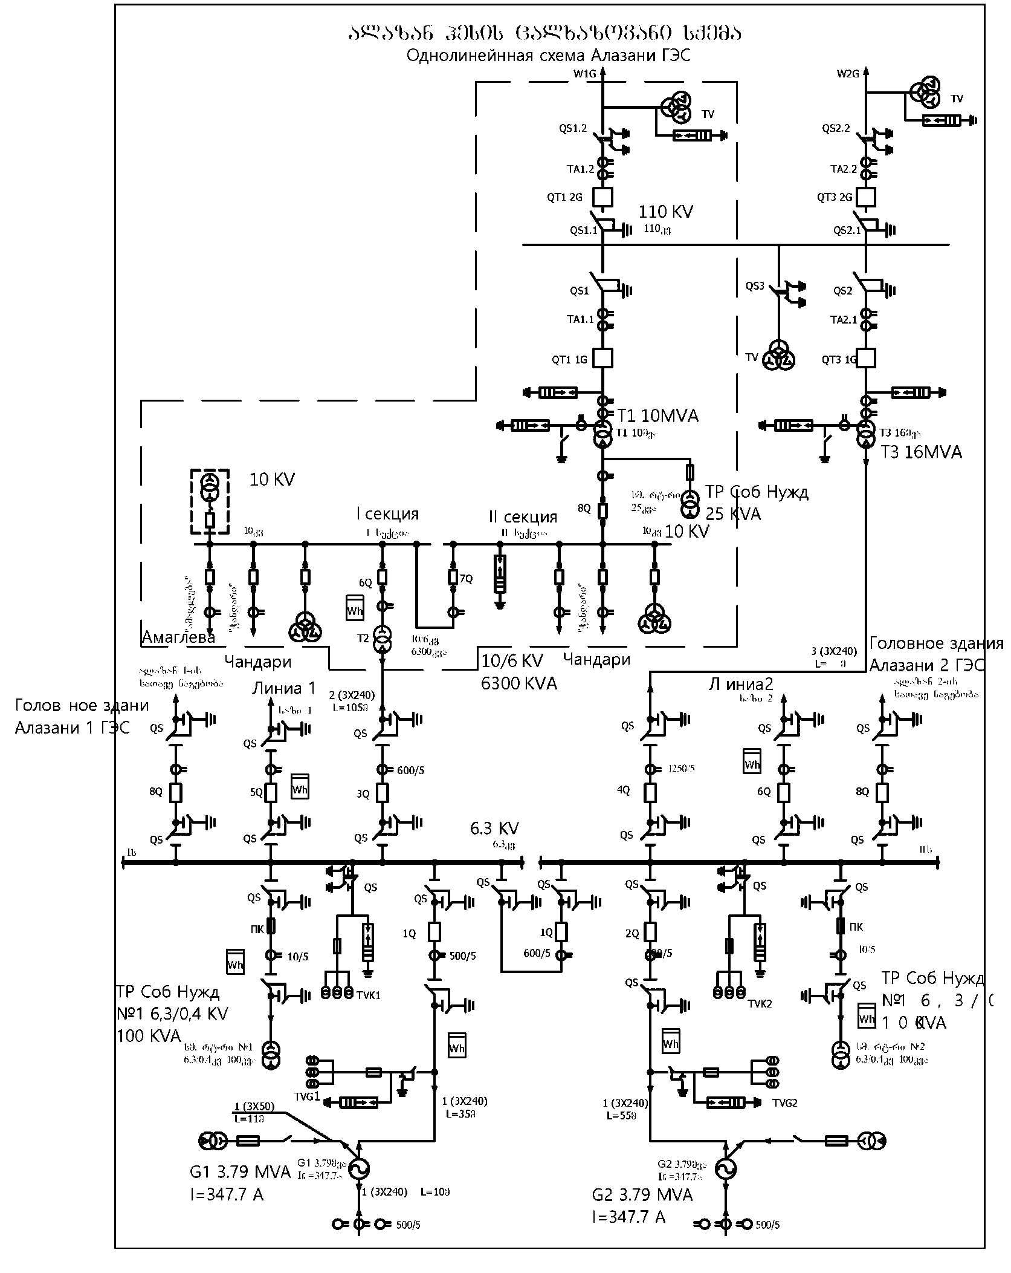
Figure 2. One-line diagram of Alazani 1 HPP.
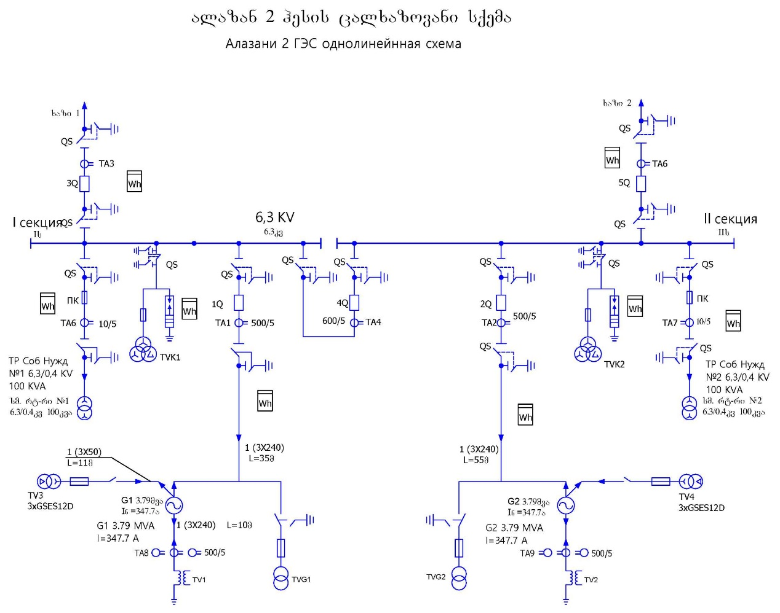

3. One-line diagram of Alazani 2 HPP.

8.3 Connection of HPPs with Internet
The connections of HPPs to the Internet are determined by the connections at present. These links can be represented in the following forms.
№ | Connection with the Internet
 | Name of HPP | Optical fiber communication | Name of HPP
1 | Alazani 1 HPP | No | 4G modem "Magti"
1 | Alazani 2 HPP | No | 4G modem "Magti"

